**Homework 1: Chapters 1 and 2 (15 points)**

**Hyukjoon Yang**

**Please use your own words to do these two exercises.**

**Introduction to DBMS (5 points)**

A long-time volunteer public skating coordinator for an ice arena in Madison wants to store information about many public skating events at this ice arena over the year so that he could provide some concrete reports to the director board every quarter. Not surprisingly, the volume of data compels him to think about using a database system. However, he wants to pick the features of a database management system (DBMS) to fit his needs only, i.e., he wants to buy/use a DBMS with the fewest possible features. He plans to run it as a stand-alone application on his laptop. Of course, he does not plan to share his data with anyone. Indicate which of the following DBMS features he should choose/pay for; in each case also indicate why he should (or should not) pay for that feature in the DBMS system he plans to buy.

1. Concurrency control.  
Not necessarily he needs concurrency control. There is no concurrent user using the database as he is not willing to share and work on the database with others. However, according to the architecture of database, concurrency control must be interacted with file and access method layers, buffer manager and disk space manager. Therefore, depending on the architecture of the database he will use, he may need concurrency control.

2. Crash recovery.  
Yes, the user needs recovery manager. Recovery manager maintains a log and restore the system to a consistent state after a crash. When the user faces system failures while he is working on the database, crash recovery would help him to restore successfully completed operation.

3. A reporting tool (tools used for data visualization or geneting reports from stored data).  
Yes, reporting tool will be needed for the user. The purpose of the database is to store information about public skating events so the he could provide some reports to the board. To do so, he would need a reporting tool to help him to visualize the data or generate reports from the data.

4. A query language.  
Yes, he needs query language. The query language is a language provided by DBMS to help the user to create, modify, and access a database. In order to generate a report from the database, he needs a query language to update the database to store information and to access the database to get necessary information for specific reports.

**ER Diagram (10 points)**

A big music studio has decided to store information about musicians who perform on its albums (as well as other company data) in a database. The studio has wisely chosen to hire you as a database designer. **Each musician** that records at this studio has **an social security number (SSN**), **a name**, an address, and a phone number. Some musicians may **share the same address**, but **no** **address has more than one phone**. Each instrument that is used in songs recorded at this studio has a **name** (e.g., guitar, piano, violin, flute) and a **musical key** (e.g., C, B-flat, E-flat). Each album that is recorded on the studio label has a **title**, a **copyright date**, a **format**, and an **album identifier**. Each song recorded has a **title** and an **author**. Each musician may play several instruments, and a given instrument may be played by several musicians. Each album has a number of songs on it, but no song may appear on more than one album. Each song is performed by one or more musicians, and a musician may perform a number of songs. Each album has exactly one musician who acts as its producer. A musician may produce several albums, of course.

Draw an ER diagram to capture all of information for this studio. Please indicate all keys and cardinality constraints and explicitly state any additional assumptions that you make. Identify any constraints that you are unable to capture in the ER diagram and briefly explain why you could not express them.  
  
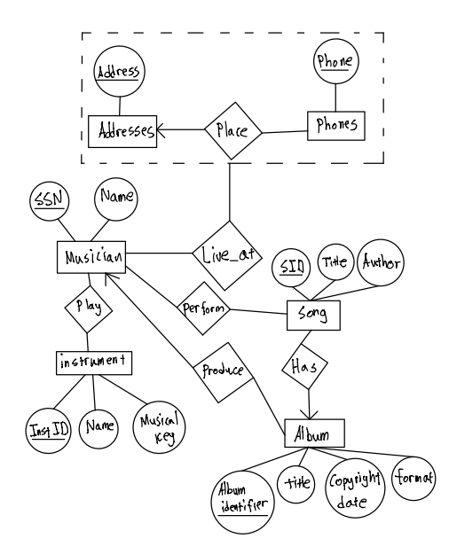  
Assumption

1. Assume instruments stored in Instrument database and songs stored in Song database have unique identifier, Inst ID and SID respectively.
2. Musician has a relationship with the address and the phone, but the address and the phone have a relationship (No address has more than one phone). Therefore, musician entity has a relationship with the relationship between the address and the phone. Since ER Model cannot express relationships among relationships, aggregation is used to treat two entities into a single entity.

**Relational model (10 points)**

Translate this ER diagram in the previous question into a corresponding relational model.

Please clearly specify any additional assumptions you have made. You will be graded based on the requirements stated above, conceptual cleanness, how well you adhere to good practices of ER design (as discussed in the class), how well you translate the ER diagram into relational schema, and how well you present both the ER diagram and relational schema.  
  
Musician (SSN: Integer, Name: String)

Addresses (Address: String)

Phones (Phone: Integer)

Instrument (Inst ID: Integer, Name: String, Musical Key: String)

Album (Album Identifier: Integer, Title: String, Copyright Date: Date, Format: String)

Song (SID: Integer, Title: String, Author: String)

Place (Address: String, Phone: Integer)

Live_at (SSN: Integer, Address: String, Phone: Integer)

Play (SSN: Integer, Inst ID: Integer)

Perform (SSN: Integer, SID: Integer)

Produce (SSN: Integer, Album Identifier: Integer)

Has (Album Identifier: Integer, SID: Integer)

Assumption

* Since there is no statement that implies Place relationship set has total participation into Live_at relationship set. (i.e. All addresses have at least one musician living) Therefore, relation for Place relationship set is created.
* Assume the identifier for each entity set is Integer
* Assume phone is Integer type
* Assume format is String type